Welcome to Special Topics! This math course will be a positive and exciting experience for you if you keep up with the work and keep an open mind about the importance of mathematics.

Course Objectives:
- to see how mathematics is useful for solving the problems of real life,
- to work together in groups to investigate, explore and have a deeper understanding of mathematical concepts
- to review from Math 1 and prepare for Math 2.
Keep this sheet in the front of your notebook for easy reference.

GRADING SYSTEM

TESTS: Tests will be given every 5-10 days. No test grades will be dropped. If you miss a test because of an excused absence, it is your responsibility to prepare in advanced for tests. If you miss the review day, you are still expected to take the test on test-day. Retests are done based on the Heritage High School Test Replacement Policy.
Re-Test Policy (Heritage HS-wide policy): Students may be re-assessed on any and all tests throughout an academic quarter. The re-assessment may not be in the same form as the original test. It may still be a test, but may be open-response questions vs. multiple-choice. Or, it may be a project that assesses the same learning objective. It may also be the same format as the original test. It is at the teacher’s discretion, but every student will have the opportunity to be re-assessed, on every test. The highest grade you can make on a retake is a 70.
In order to qualify for a re-assessment, each student must…
- Have every homework assignment for the given unit completed by the re-test date.
- Complete the re-test on the date chosen by the teacher (within a week of having the test returned to the student).
- Remediate with the teacher on the material prior to the re-test.

  - PROJECTS: Projects will be given throughout the semester. These projects may include, but are not limited to writing assignments, the construction of objects, the use of computers, the Internet and outside research.

  - QUIZZES: Quizzes will be given throughout the semester. Quizzes are designed to assess your learning and are usually, but not always, announced. All quizzes will be replaced with the unit test grade (if it is higher).
Quiz Replacement Policy: It is the philosophy here at Heritage HS that assessments are given in an attempt to see where each student is at in their learning, and make adjustments to further their education. Therefore, if a student performs better on a unit test than they did on a quiz within this unit, they may replace their lower quiz grade with the better unit test grade. Only original test scores may replace quiz scores, not re-test scores.

  - HOMEWORK: Expect a homework assignment EVERY night. Homework is assigned to help you practice the concepts presented in class and should be completed to the best of your ability for credit. I expect homework to be completed every night using a pencil and with all work shown in your homework notebook (No work = No credit). It is your responsibility to make up any missed/late assignments before the end of the current unit. It is a great tool if you are absent to ensure that you do not get behind. Late homework will be accepted for up to a 60 prior to the school’s Late-work Deadlines (posted in the classroom too). Late homework WILL bring your grade down, so avoid submitting assignments late!! It is your responsibility to write down each night’s HW on the outline provided at the start of each unit.
  - ACADEMIC HONESTY: You are encouraged to work outside of class on assignments with other students. However, cheating is unethical! Cheating includes but is not limited to copying homework assignments, obtaining test/quiz answers prior to the assessment, sharing answers during tests/quizzes, and plagiarism. Students will receive a ZERO on the assignment if caught cheating! Working cooperatively is ONLY the sharing of ideas, not work!! During group assignments, students are NOT to divide up the work unless instructed to do so!
Each student will sign the HUSKY HONOR CODE!

  - GRADING PERCENTAGES:
Major (all tests/some projects) . . . . . …………… . 60%
Final Exam is 20% of overall semester grade.

Minor (Quizzes/some projects) …. . …………... ... 30%
Homework/Classwork. . …………………………. 10%

FORMULA FOR SUCCESS

  - BE PRESENT AND ON TIME. In the event of an absence, it is your responsibility to get the makeup assignments available in your packets and complete any makeup work before the end of the current unit. The unit outline will give you a day-by-day guide as to what we will be doing in class.

  - BE CONSIDERATE. Raise your hand to speak. Never interrupt when others are speaking. Keep the area on and around your desk clean. Do not write on the desk. It is not your scratch paper!

  - BE PREPARED. Things to bring: items on the materials sheet and homework (ready for checking). Things not to bring: food, drinks (other than water), and assignments that are not completed. Be prepared with questions! You will never know the answer if you don’t ask the question! DO NOT plan on using the bathroom during class. This needs to be taken care of before class as missing any part of the lesson could put you behind as well as disrupt the classroom environment. Should restroom emergencies arise then please wait until it is an appropriate time to ask, so as to not disturb the learning process of both yourself and your peers.

  - HAVE A GOOD ATTITUDE! We are in this class to learn math and to have a good time! We will be together for the next 90 school days; having a good attitude will make them much more enjoyable. My job is to ensure that everyone has a successful semester and is prepared for the next mathematics course. Your job is to participate, be respectful and complete all assignments.

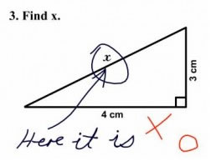
- MISCELLANEOUS

  - Math is hard…what if I need help? I am available after school Tuesdays until 3:30 pm. Most weeks I stay multiple days after school so always check the board! Most mornings I am also available. In addition we have Husky Help each week! Please ask questions – I cannot read minds! See me if you are having any sort of problem; I am willing to help if you are willing to stay!

  - Please do not pack up materials until instructed to do so. Stay in your seat until the bell rings and you are dismissed.

  - Extra Credit: Please do not ask for extra work to improve your grade. Each student is given the same opportunities to excel by the numerous assignments given. It is the student’s responsibility to keep up with those assignments to the best of their ability.

  - Be prepared to work and have fun in this class. I enjoy teaching, and I put a lot of effort into it, so I’m expecting the same effort from you. I’m looking forward to this semester, and I hope that you are as well. Good luck
R: Respect I: Integrity S: Self-discipline K: Kindness
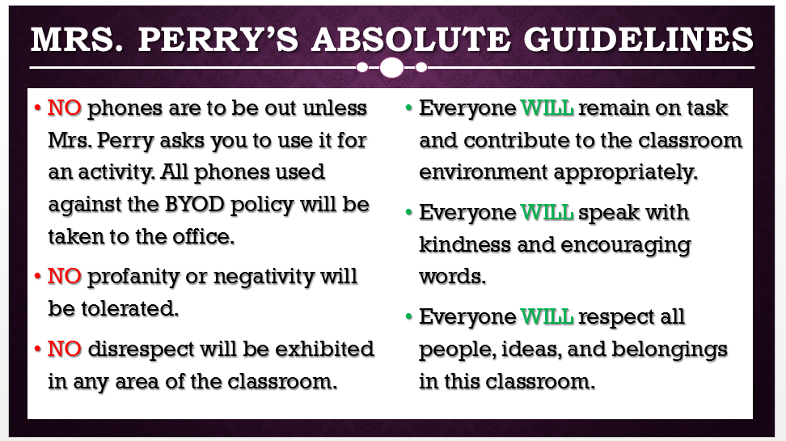

Mrs. Perry’s Contact information:
School Phone: (919) 570-5600
E-mail: koperry@wcpss.net

Website: mskoverton@weebly.com
Remind 101: Text @koperry2 (2nd Period) or @koperry4 (4th Period) to 81010

Important School Information

Make-up Work Policy (Heritage HS-wide policy, coupled with Math Department policy): Heritage HS allows students to complete missed homework and project assignments for 50% of the earned grade, if completed by pre-set Make-up deadlines. These deadlines occur mid-quarter and prior to the end of each quarter. No late work may be turned in past these deadlines. In addition, Heritage HS Math Department believes that students benefit most from homework completed prior to the unit test (as it serves as practice for the given test). Therefore, any student completing a missing assignment prior to the unit test may earn 60% of the earned grade.

Husky Help 3.0 (Heritage HS-wide program): Husky Help (version 3.0) will run Monday – Thursday. Monday will be remediation for each student’s Period 1 class, Tuesday for their Period 2 class, Wednesday for their Period 3 class, and Thursday for their Period 4 class. Students that have a C, D, or an F in the course on that given day (according to their weekly progress report), will be mandated to attend this remediation session (built in to the school day). All other students will have the opportunity to participate in intramural sports, attend career or college sessions, work individually or with groups on assignments in the Media Center or the Commons, or meet with Student Service counselors for academic planning. Although this remediation time will allow teachers to focus on assisting students with a grade of 79 or below, teachers will still continue to have regular office hours to assist ALL students.

Internet Policy:
In accordance with Board Policy 2313/3013/4013 and the 21st Century Act (Public Law No: 110:385, Oct. 10, 2008) all students will be trained annually in Internet safety. School districts are required to educate students about:
- Appropriate online behavior, including interacting with other individuals on social networking websites and in chat rooms.
- Cyber bullying awareness and response.
Need Language assistance??

Student Supply List
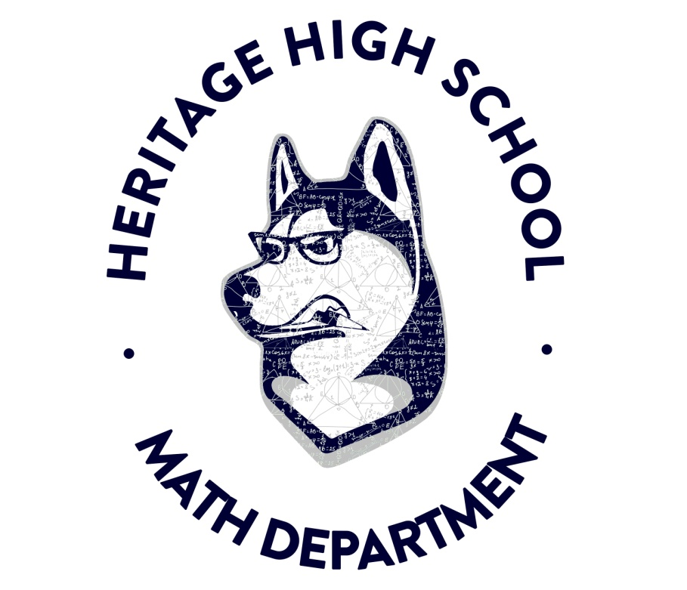
Required Items:
- TI-84 Plus graphing calculator
- 3-Ring binder - about 1.5”
- Dividers
- Loose-leaf paper
- Graph paper
- Spiral Ring Composition Notebook (to keep homework and misc. classwork)
- Pencils
Preferred Items:
- Dry Erase Markers
- Colored Pencils/Markers
- Highlighters
- Ruler
- Compass
- Hand Sanitizer
- Tissues

