Our School's BYOD Mission:
The Heritage High School community empowers all students, ​through digital learning and teaching, to live a life of integrity, purpose, achievement, and digital intelligence by providing a differentiated, uniquely authentic education.

BYOD (Bring Your Own Device) at Heritage High School:
As of the 2016-17 School Year, HHS is officially a BYOD (Bring Your Own Device) School. As such, Students are required to sign the HHS/WCPSS BYOD Contract and Technology Usage Agreement. These forms only needs to be signed one time and will be kept on file. Other information concerning policies and procedures can be found at www.hhsbyod.weebly.com. However, the specific policy for mobile devices in every classroom is such:

- Students may use their devices in the classroom during instructional time…
  - Teachers will display a RED card/signal indicating that your device is powered off, put away, and is NOT in use.
  - Teachers will display a YELLOW card/signal indicating that your device is on silent and is face down on the desk. Student should ask before using.
  - Teachers will display a GREEN card/signal indicating that your device is in use as directed by the teacher.
- Around the School Building:
  - Red Zones: The device MUST be OFF and away at all times.
    - Restrooms
    - Locker rooms
    - Gym (Outside of Teacher directed instruction.)
  - Green Zones: The device, when in use, must be on SILENT or VIBRATE at all times.
    - Supervised Instructional Areas (i.e. Locker bays, Collaborative/Active Learning Spaces, the Media Center, and Outdoor classrooms)
    - Hallways
    - Cafeteria/Commons area

BYOD Inappropriate Use and Discipline:
Inappropriate use of devices in the classroom Teacher will give student two options:

- Choice 1 → Student can Personally place the device in a “Cell Jail” in a secured location in the classroom (i.e. File cabinet, Teacher Desk, anywhere that can be locked with teacher access.) and receive it back at the end of the class.
- Choice 2 → Student will be sent to the office.
- Note: On the second offense of inappropriate use, student no longer has a choice. It will default to the Admin option.

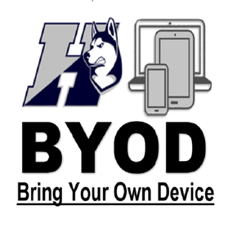
You MUST sign a contract agreeing to these guidelines in order to participate in the BYOD initiative here in our math classroom.

